1. Overview of Project
   * The purpose of this project is to provide insight about the outcomes of several Kickstarter campaigns as they relate to various categories and geographic locations.
   * The analysis should inform the customer around what goals and other criteria she should strive for to improve her odds of success.
2. Analysis and Challenges
   * The analysis looked at the question of success from two different angels, the date (month) it was started and the goal amount that was forecasted. 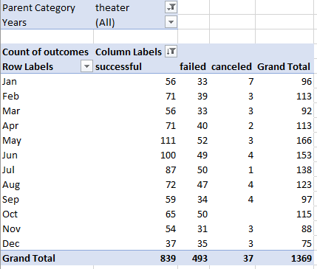

The largest take away from the month data was the high count of successful campaigns that started in May – Jul compared to other months.

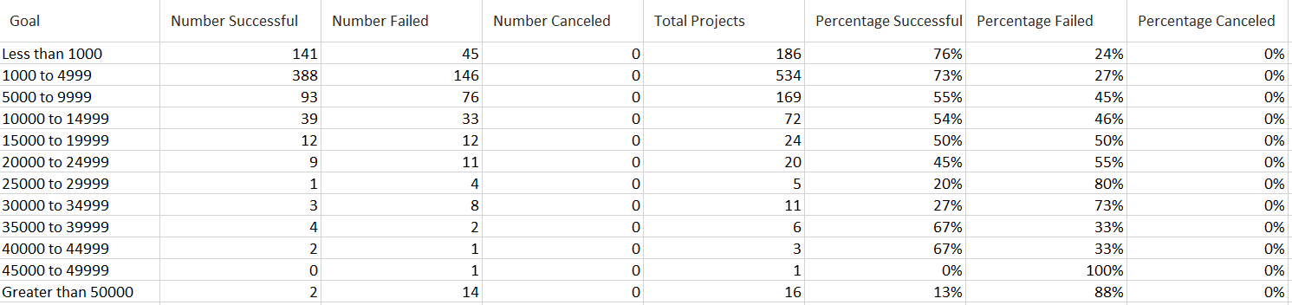

The goal based data indicated that successful campaigns had lower budgeting goals with a cross over occurring at ~20K.

* + There were no significant challenges on this exercise primarily because I am familiar with Excel and the functions that were used.
  + I can see if someone whom is not familiar with how to use pivot tables and some of the excel functions (countifs, etc.) might struggle. The examples and videos provided, however, provide excellent walk throughs to assist in that.

1. Results
   * Successful outcomes appear to be more prevalent between 2014 – 2016, and looking at only the date data, appear to be clustered around the summer months May – June.
   * Upon closer inspection we can see that the start date month does not appear to hold any real indicator value with regards to failures. The number of projects that failed remain more or less constant over time, regardless of the start date month. There must be another variable leading to failure.
   * When examining the goals aspect of the analysis, it appeared that projects with a goal of less than 15,000 were more likely to succeed. The crossover point of more projects failing than succeeding occurs at the 15000 - 20000 level.
   * By charting all successful outcomes with a budget goal less than 20K we find that month started or year started does not have a significant impact on a successful outcome. This leads me to believe that budget goal is a primary indicator of success. Further analysis would be required (a statistical analysis for that measures success of projects under 20,000 vs. those over 20,000 as an example) for a complete assessment but my preliminary recommendation for a successful Theatre Kickstarter would be to target a budgetary goal of less than 20,000.